[Date]

[Contact Name]
[Company]
[Address]
[Phone]
[Email]

Dear [Contact];

What can 58,000 volunteers around California do in one day? Remove 700 thousand pounds of trash.

That’s why on September 19, Orange County Coastkeeper leads the brigade in Orange County with more than 7,000 volunteers for our local push in Coastal Cleanup Day, the world’s largest trash pickup. We would like to invite you to be a part of this exciting event and great opportunity to show your community that you care.

Orange County Coastkeeper protects and promotes water resources that are swimmable, drinkable, fishable, and sustainable. We are a dynamic and dedicated group that continually speaks a voice of stewardship for Orange County.

As a company that has (insert awesomeness here) we think you’d be a wonderful fit to partner with us on Coastal Cleanup Day. In return for a donation of (insert amount) your company will gain excellent exposure while demonstrating your desire for clean water, thriving marine life and healthy livelihood for families.

For more details on sponsorship opportunities please contact me at courtney@coastkeeper.org or (714) 850-1965 for an opportunity to join teams.

Thank you for your time, and I look forward to hearing from you soon.

Sincerely,
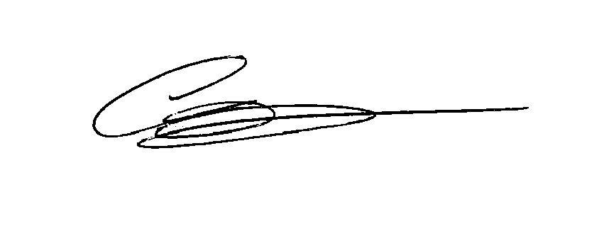

Courtney James Garry Brown
Coastal Cleanup Director Executive Director
Orange County Coastkeeper Orange County Coastkeeper
(714) 850-1965 (714) 850-1965
courtney@coastkeeper.org garry@coastkeeper.org
www.coastkeeper.org www.coastkeeper.org

Sponsorship Commitment
Yes, I would like to sponsor Orange County’s Coastal Cleanup Day:
- Cash Donation
- Other (please specify):

Sponsor Information
Company/ Organization
Contact Name
Address, City, State, Zip
Telephone
Email Address

Payment Information
- Visa
- Mastercard
- AMEX
- Discover
- Check payable to Orange County Coastkeeper

Credit Card No.
Security/ CVC Code
Expiration Date
Cardholders’ Name
Authorization Signature
Amount | $

Please return this commitment form to:
Orange County Coastkeeper
3151 Airway Avenue, Suite F-110
Costa Mesa, CA 92626
www.coastkeeper.org
Phone (714) 850-1965 Fax (714) 850-1592
Orange County Coastkeeper’s Federal Tax ID# is 33-0847892.

